**Q)** What is GitHub? When was it created? Why? By who? What similar platforms exist? Why would you use such a platform?

Answer: -

* GitHub is a code hosting platform for version control and collaboration
* The GitHub manages and stores different versions of projects.
* Git was created by Linus Torvalds who is also a creator of Linux.
* The GitHub site was launched in April 2018 by Tom Preston Werner, Chris Wanstrath and PJ Hyett.
* Other similar platforms like CVS, Subversion do exist. They have a central repository of all the files associated with the project.
* When developer make any changes to the code, the changes are made to the central repository. With git, if you want to make any changes to the project code, you copy the entire repository on your local system, make changes to the code on your local system and then check kin the changes to the central server.

Q) Tutorial screenshots

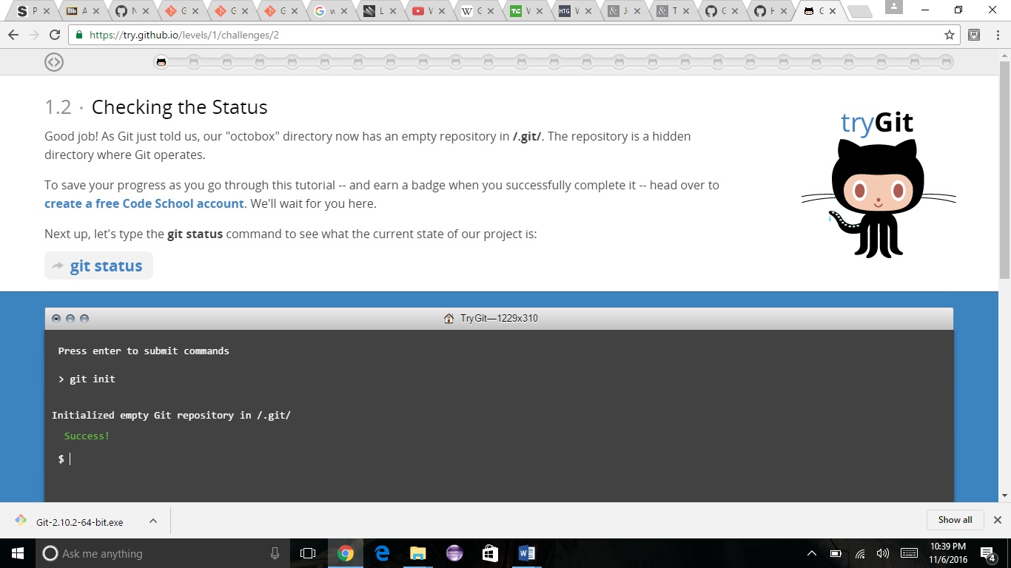

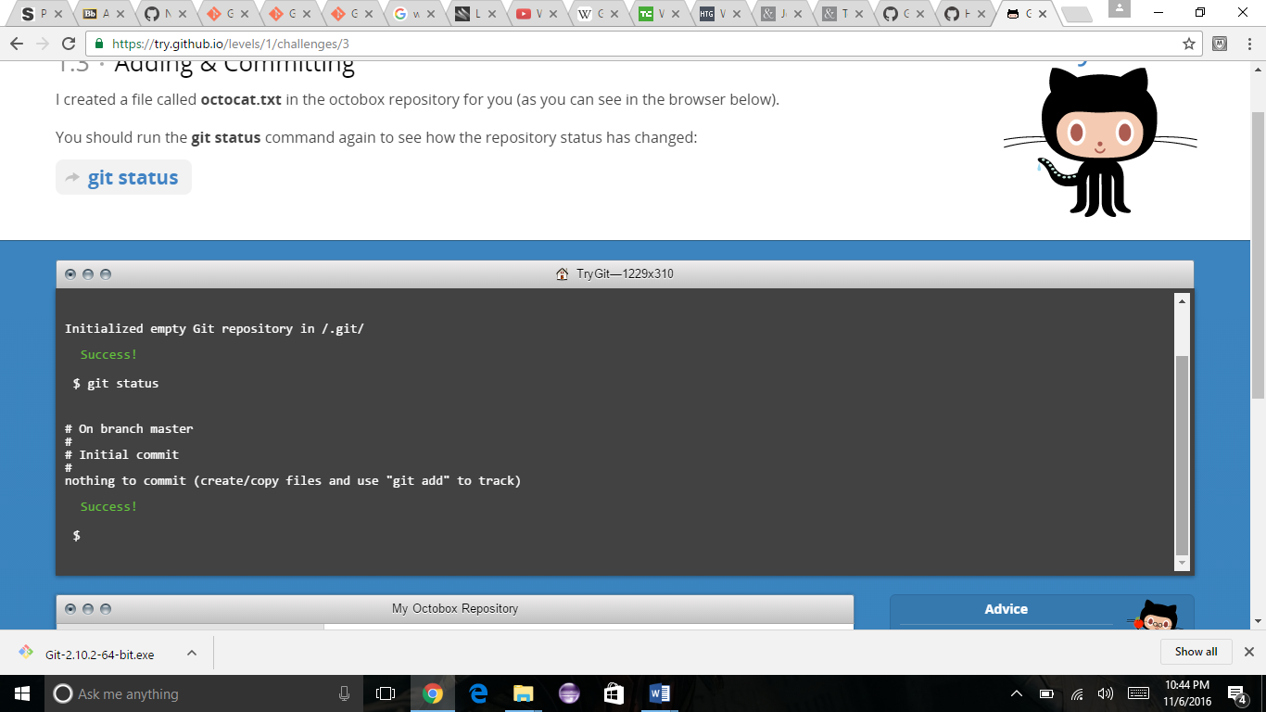

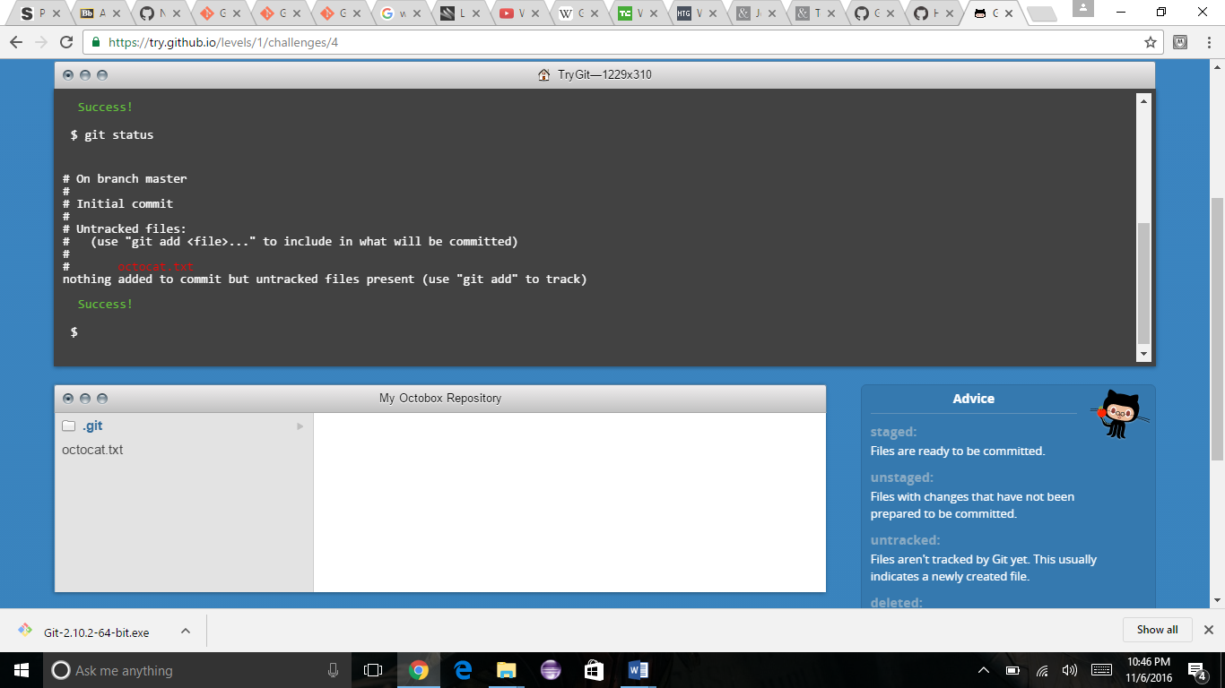

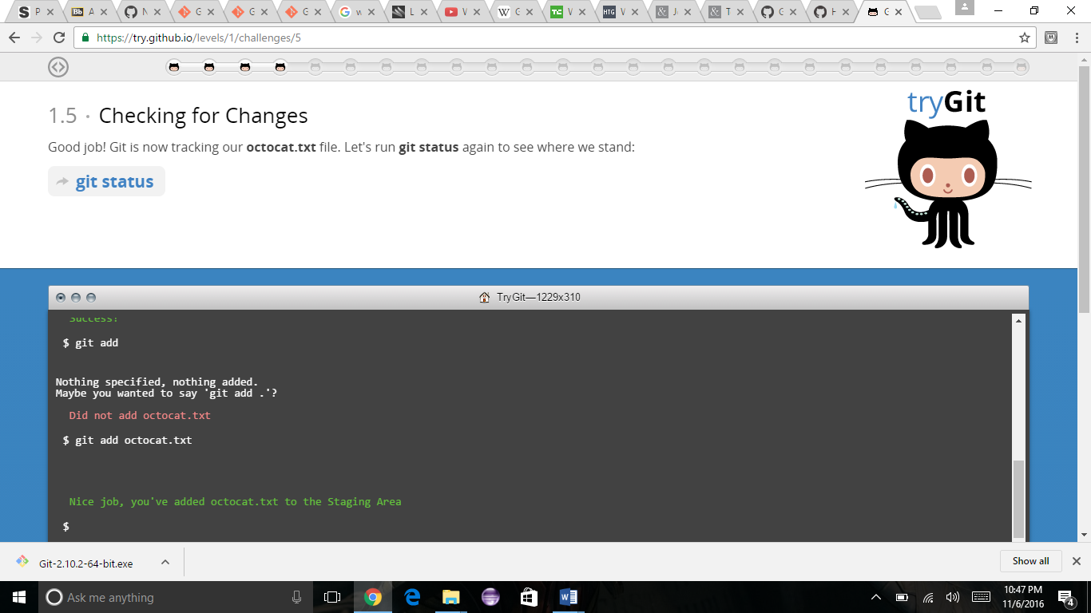

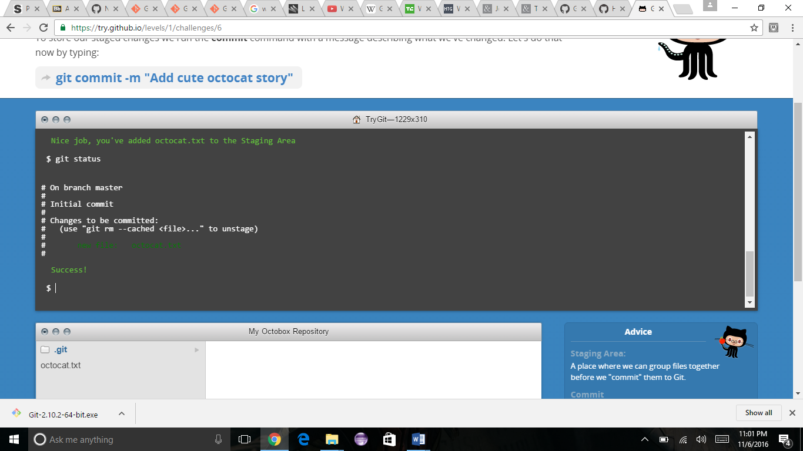

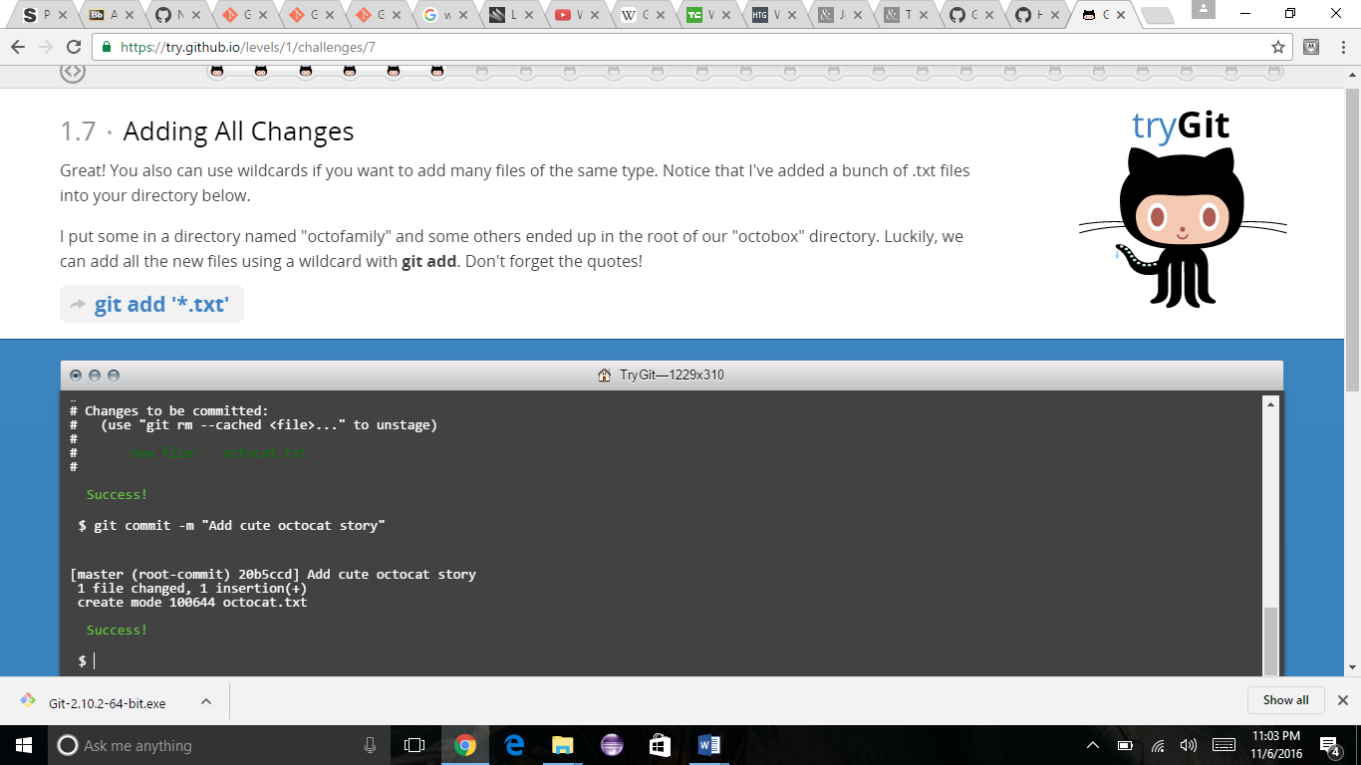

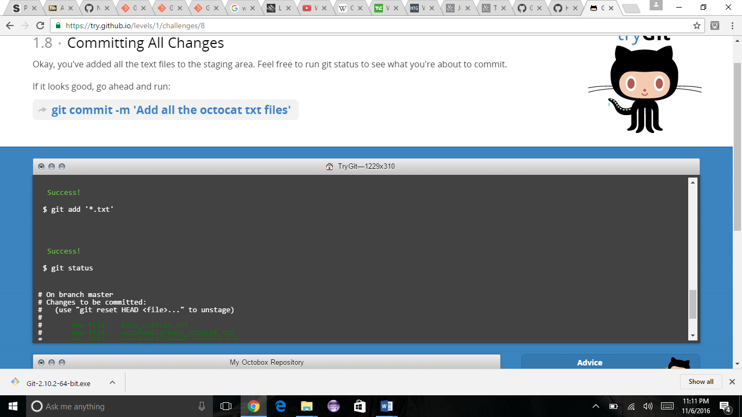

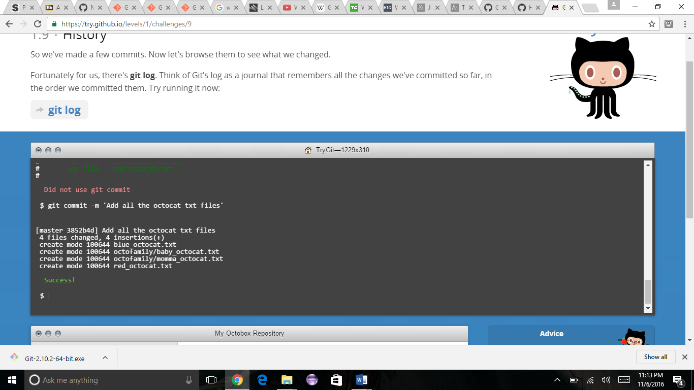

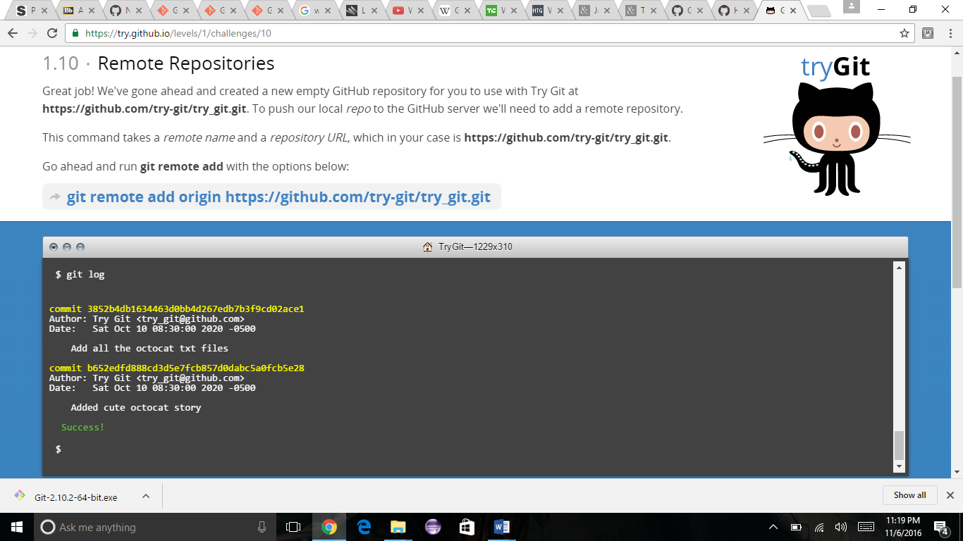

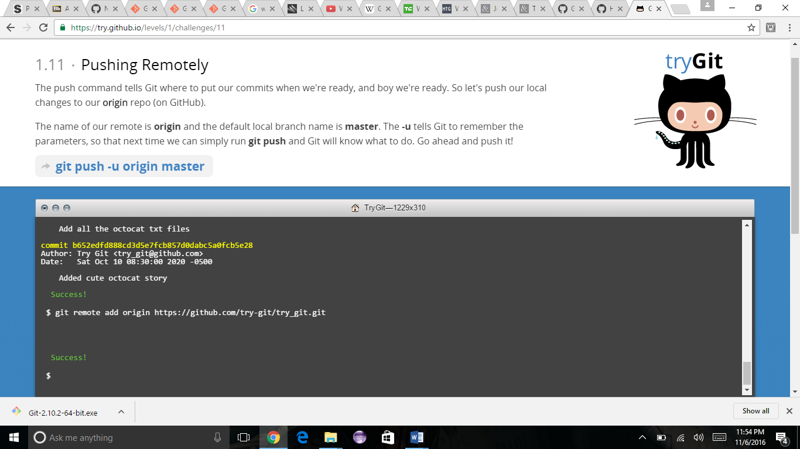

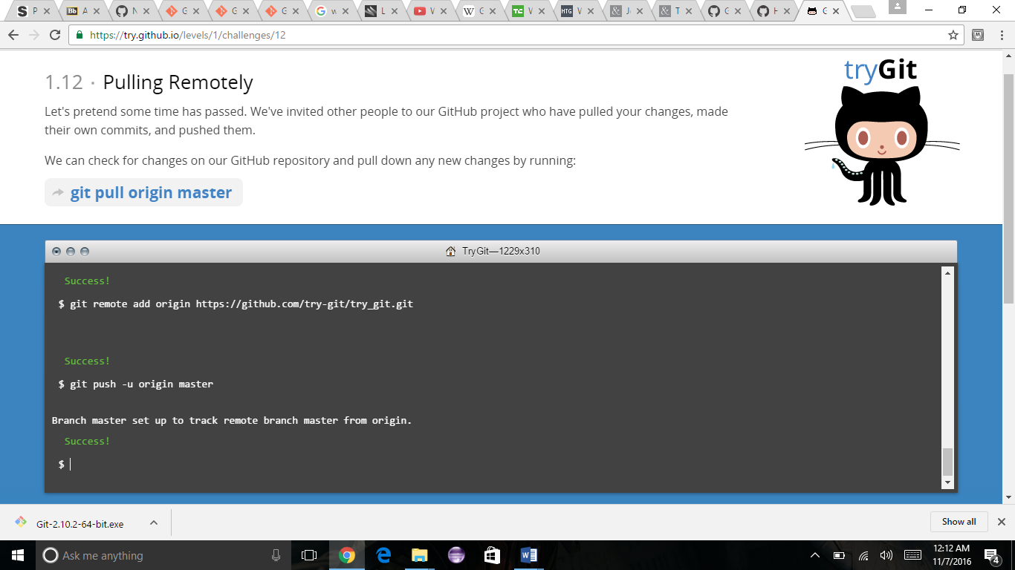

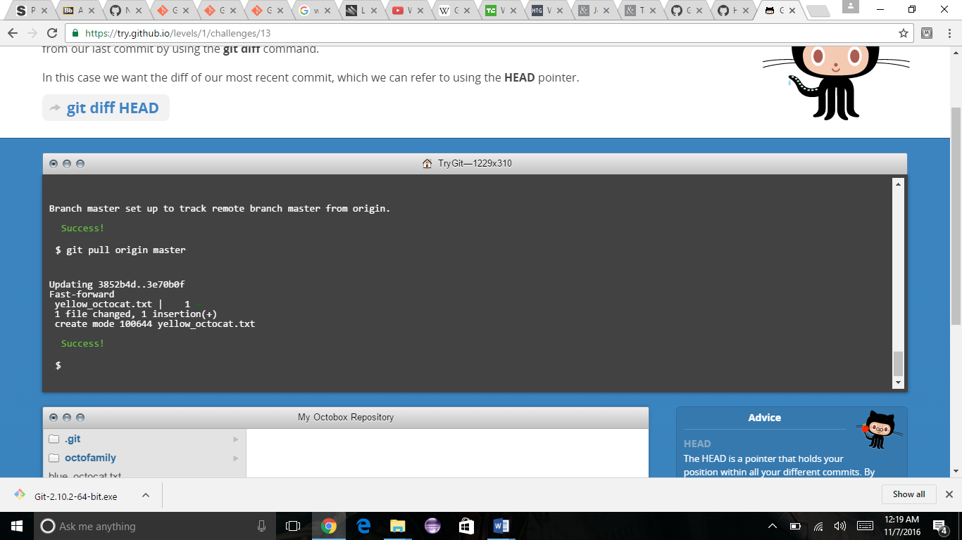

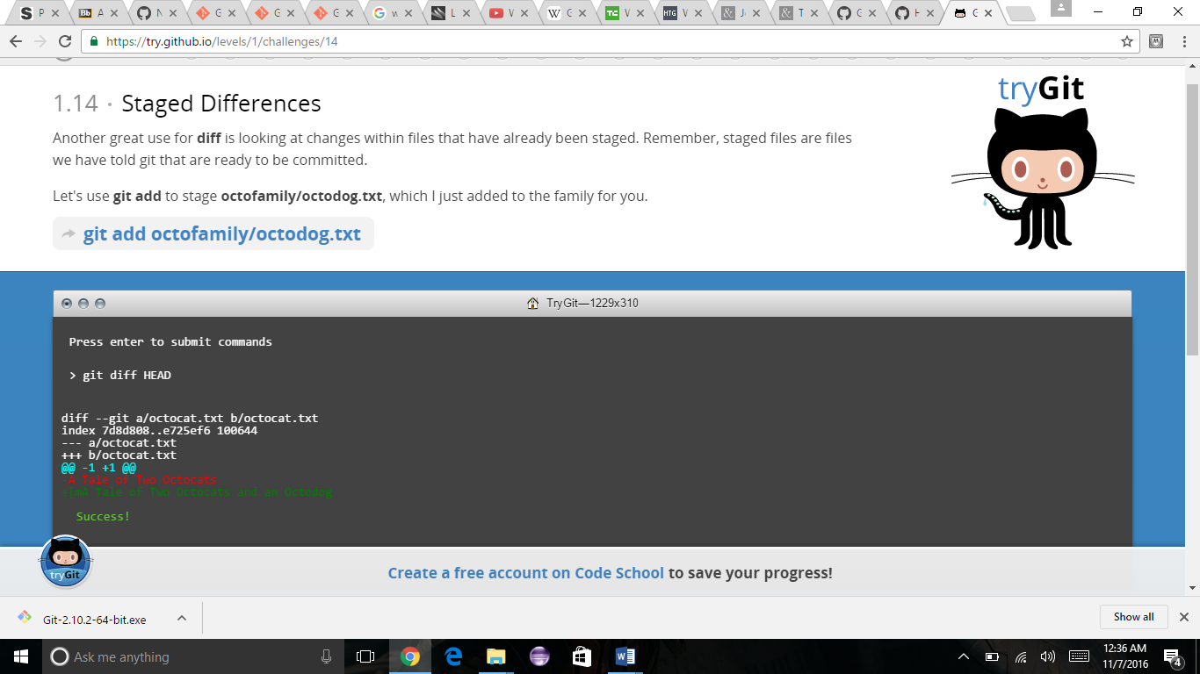

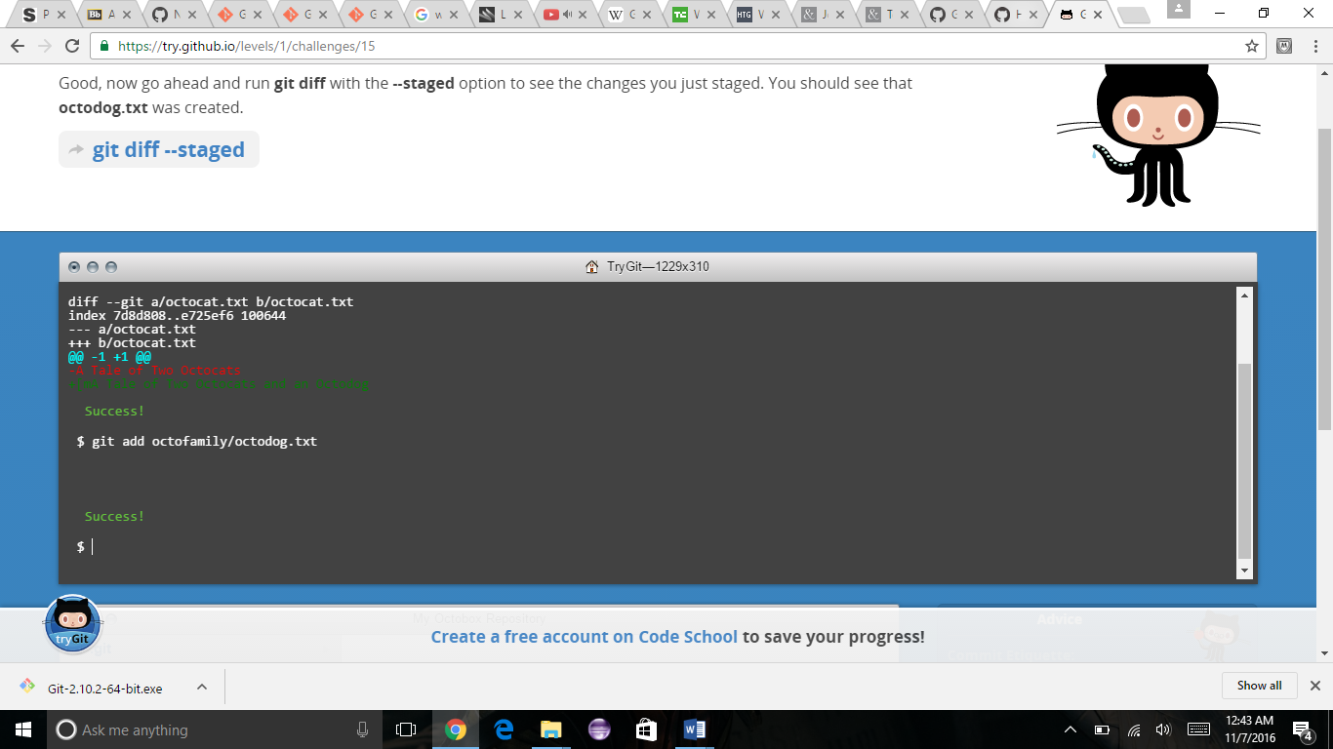

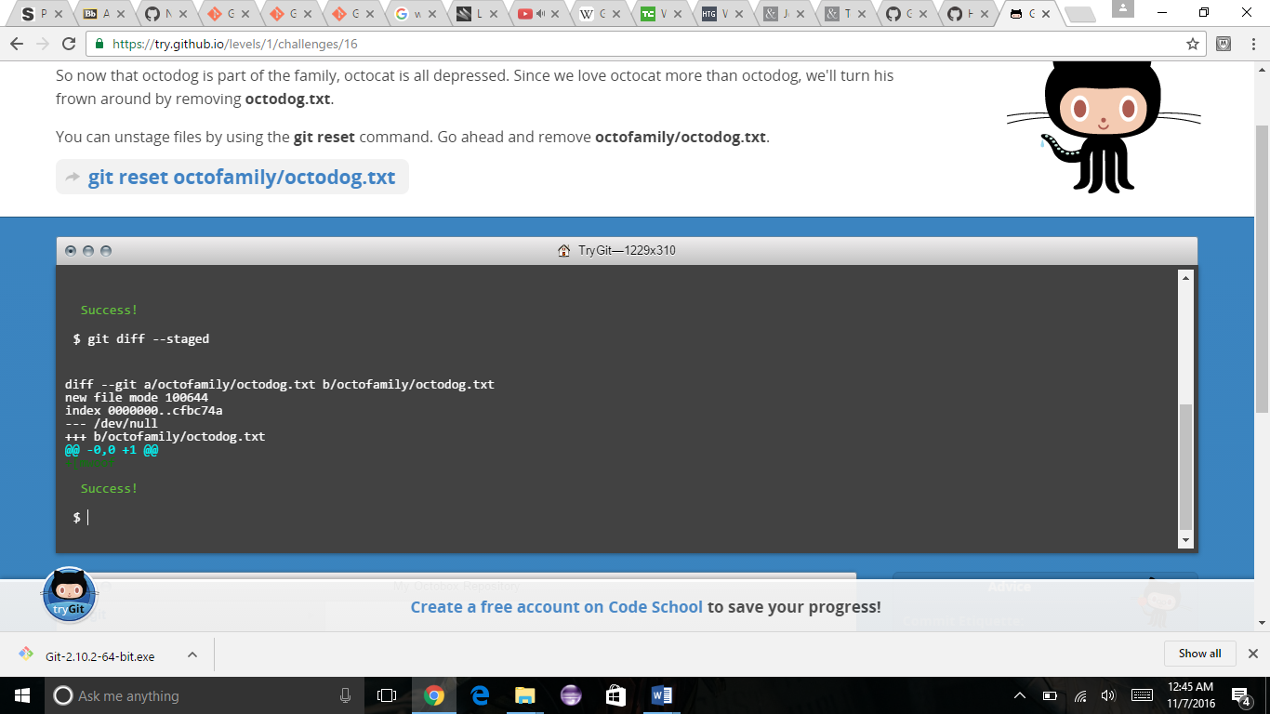

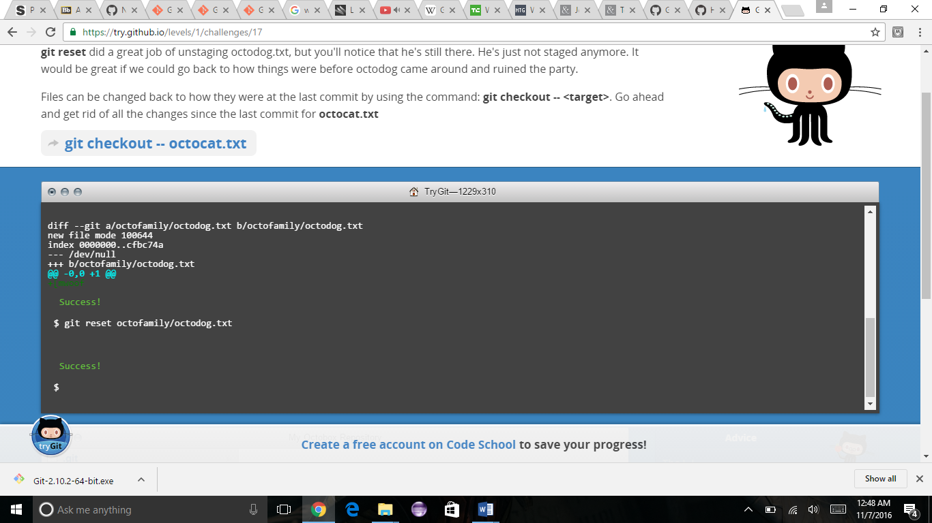

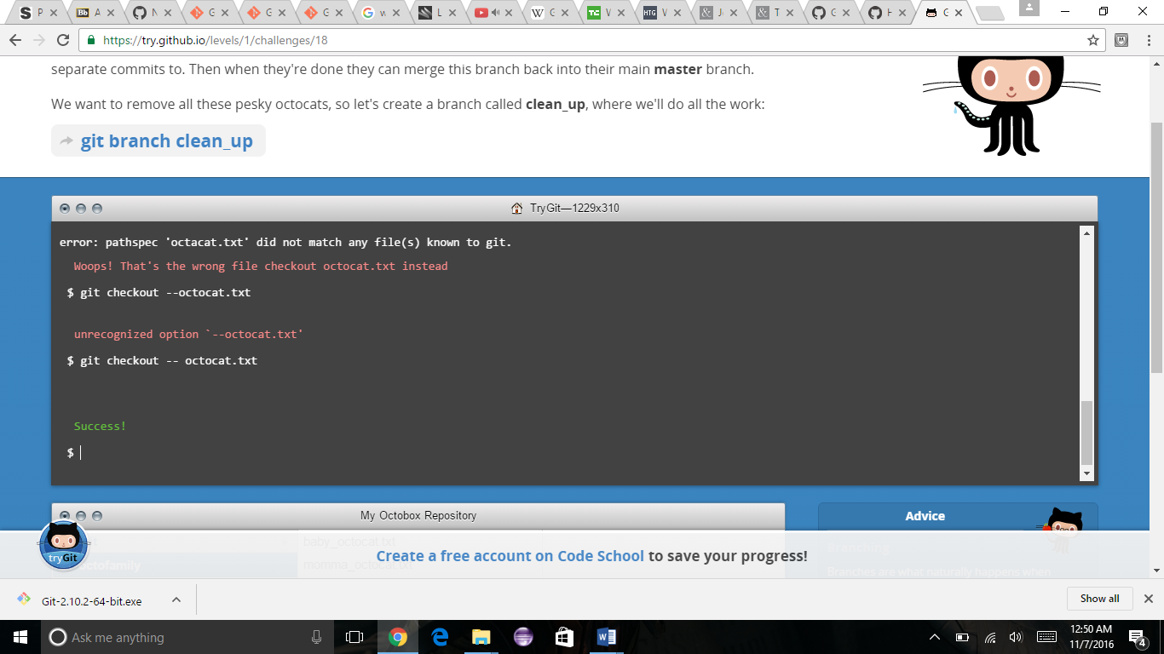

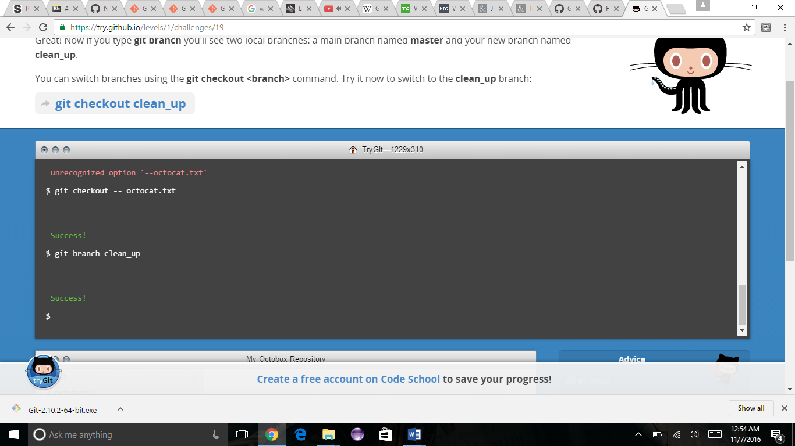

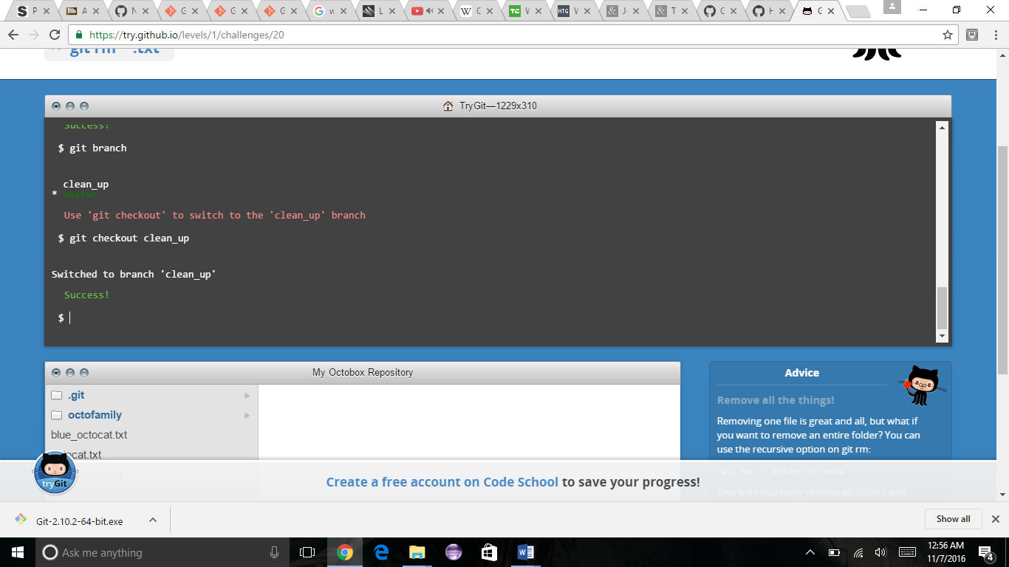

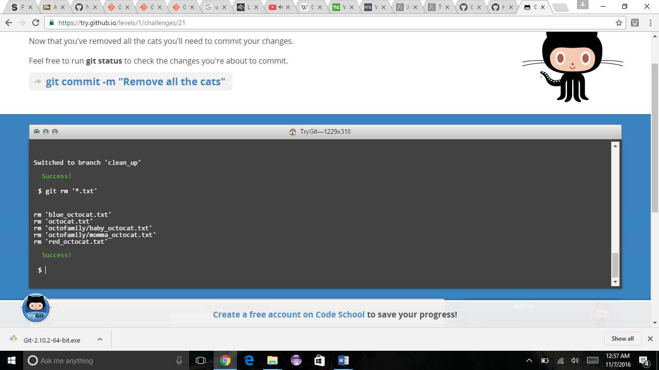

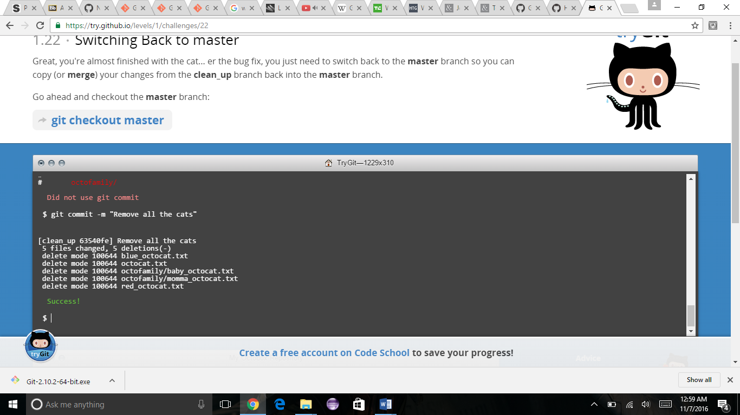

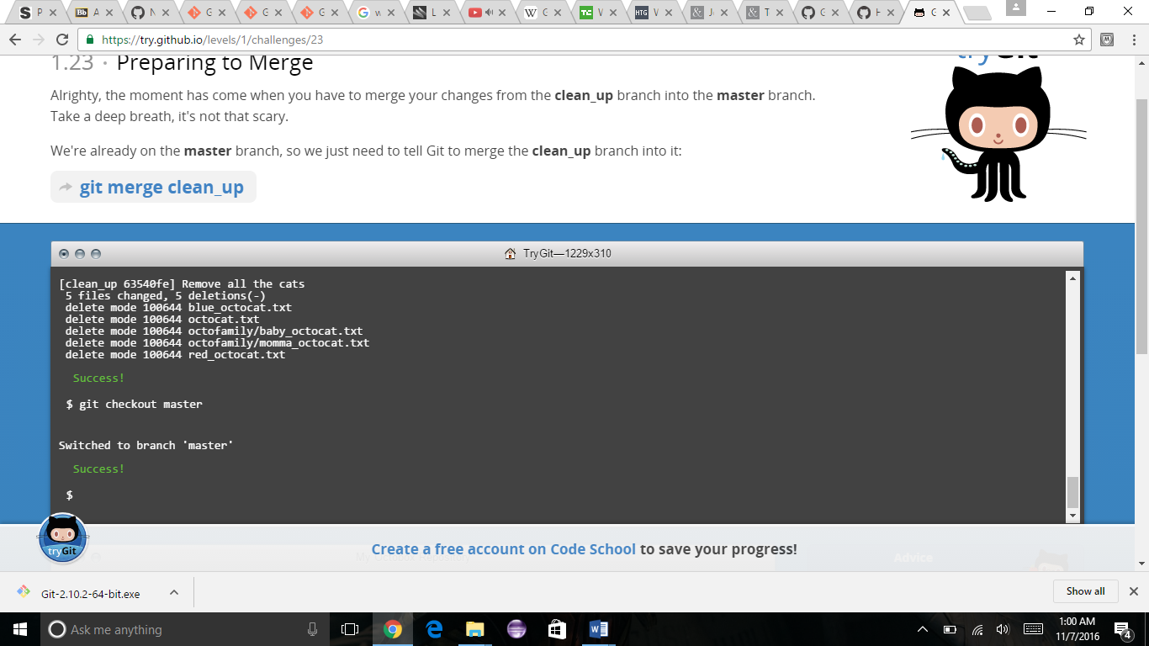

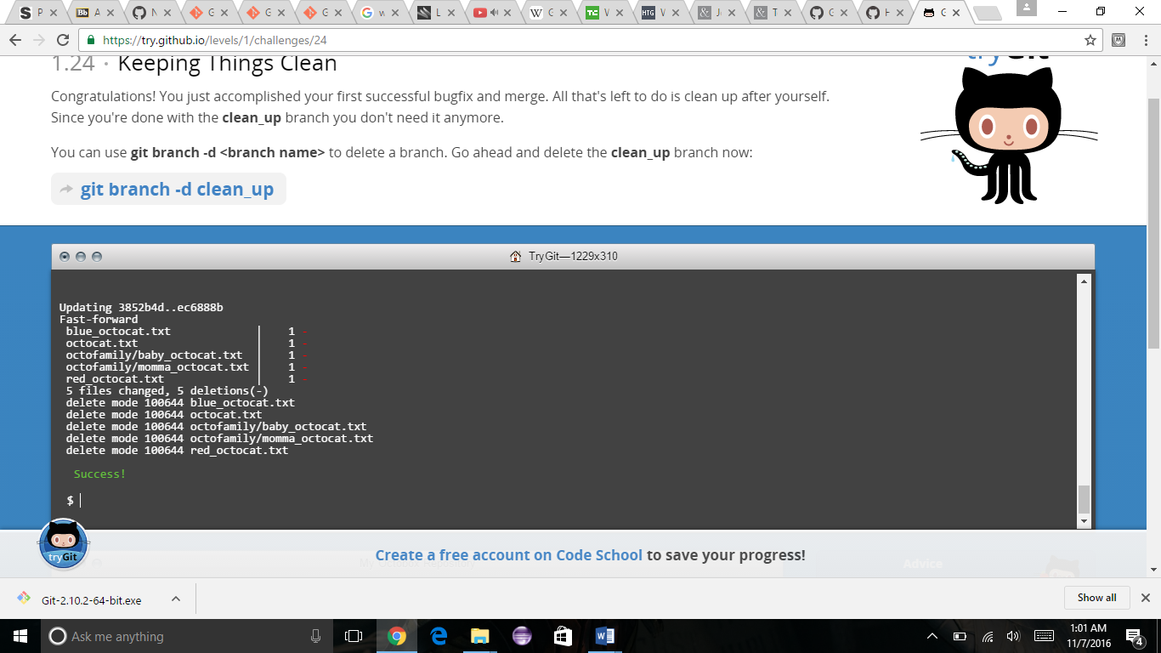

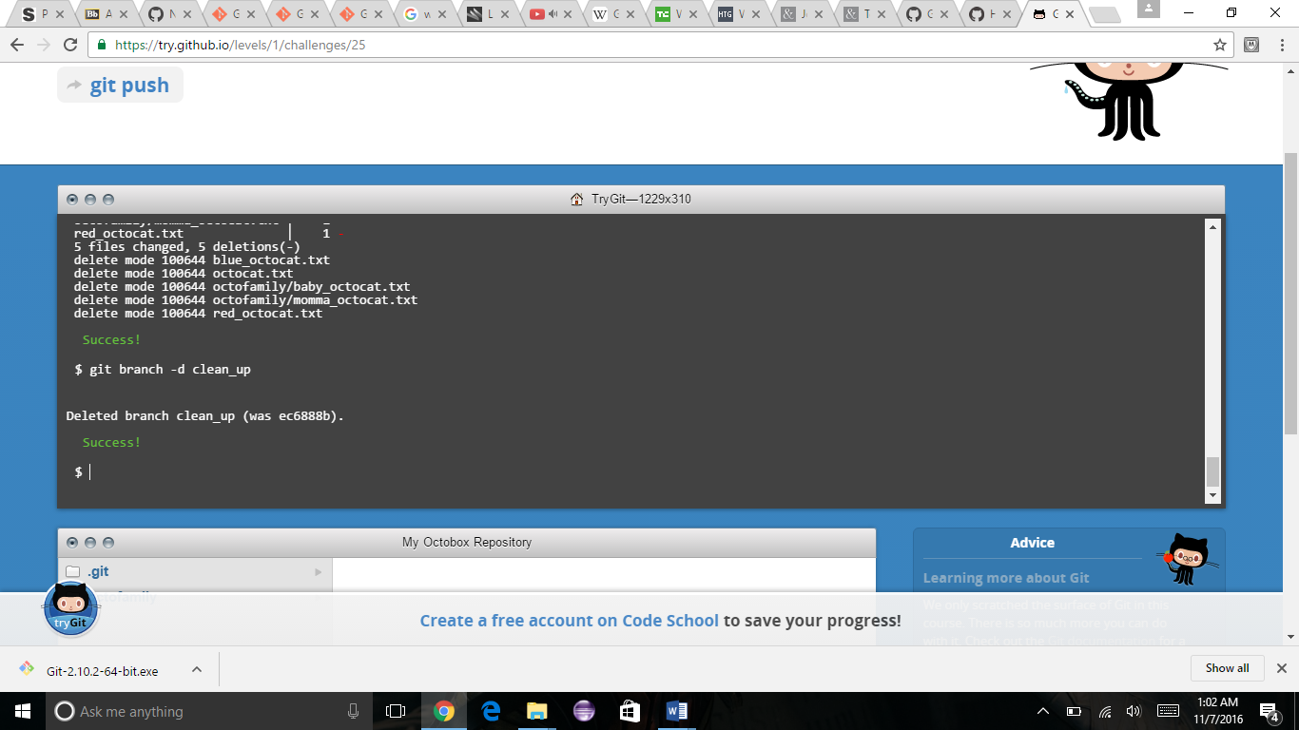

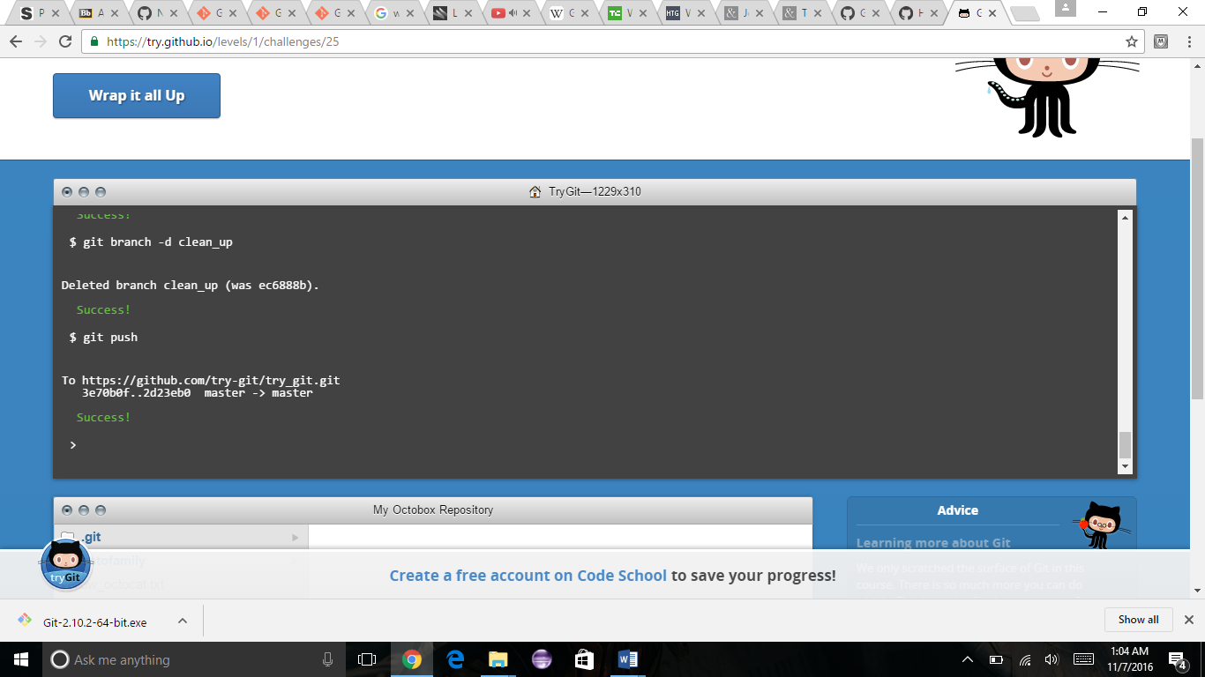

**Q)** Define the following terms in the context of Git (2 lines maximum):

* Repository
* Used to organize a single project.
* Can contain folders and files, images, videos, spreadsheets and anything your project needs.
* Commit
* On GitHub saved changes are called Commit.
* Each commit has an associated commit message which is a description explaining why a particular change was made.
* Push
* Where to put our commit when we are ready.
* Branch
* A lightweight movable pointer pointing to the commits.
* The default branch is the MASTER
* Fork
* It’s a copy of repository.
* Forking a repository allows you to freely experiment with changes without affecting the original project.
* Merge
* It will merge the changes onto the master branch.
* Clone
* It cones the local repository on your computer and syncs it with the one on the Git.
* Pull
* Let’s you tell others about the changes that you have made on GitHub repository.

* Pull request
* When you open a pull request you are proposing your changes and requesting that someone review and pull in your contribution and merge them into your branch.

Q) Retrieve the README.md file at:

<https://github.com/paceuniversity/courses>

Add your name (lastname, firstname) in the file, **add a comment (date and time) (REQUIRED)**, and update the README.md file at: <https://github.com/paceuniversity/courses>. Your name should appear at the provided <https://github.com/paceuniversity/courses>. Please check the work of previous students.

List the commands and strategy you use to do this part of the exercise in the *LastnameFirstnameGitTutorial-mm-dd-yyyy.docx* file and push it to: <https://github.com/yourpseudo/CSXXX2016>.

Step 1: - Goto git repository <https://github.com/paceuniversity/courses> and click on Fork button. This will copy the repository to your cloned local repository.

Step 2: - Now you see a folder named courses on your locally cloned repository. Open it and open the Readme.md file and edit it. Enter the required details.

Step 3: - Run the command “git status” on your gitbash.

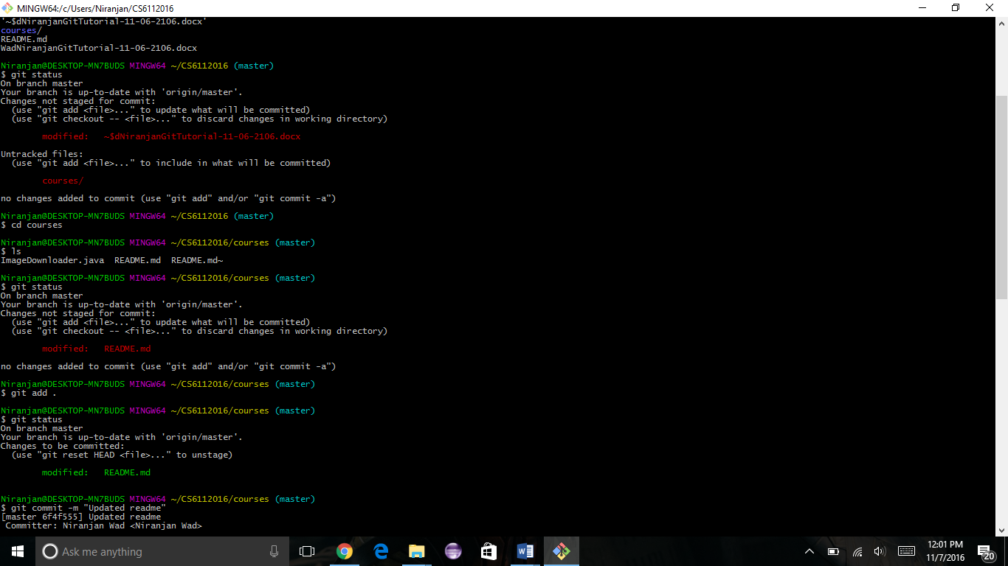

You can see that the edited Readme.md file is not yet staged for commit. Let’s do that

Step 4: - Run the command “git add .”

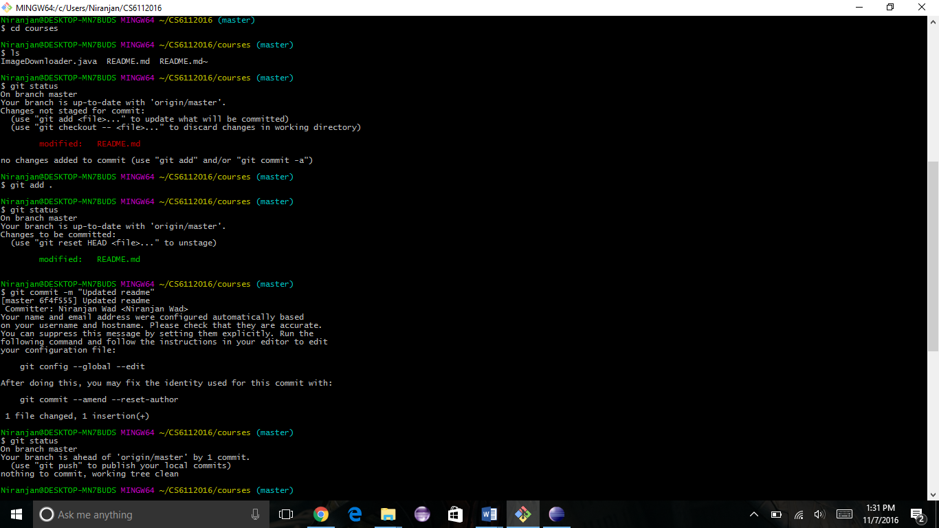

So now we see that the Readme.md file is ready for commit. Let’s do it.

Step 5: - Run the command “git commit –m “Updated file”

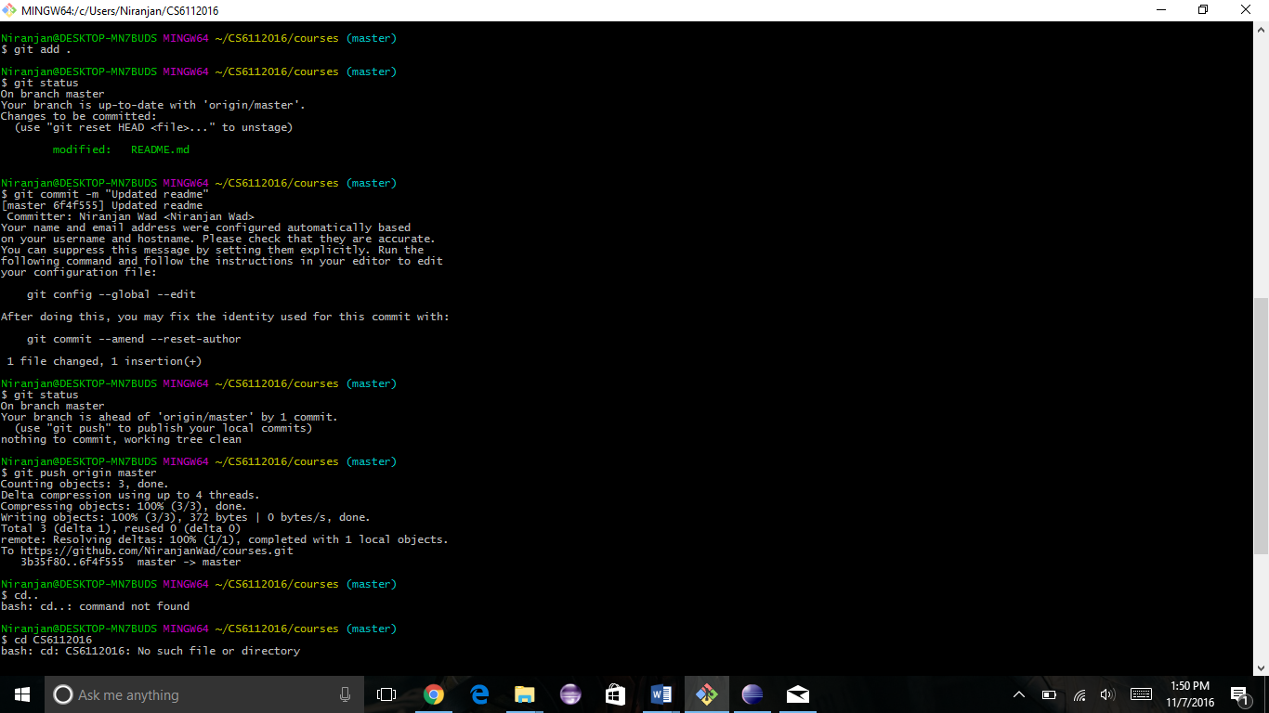

Step 6: - run the command “git push origin master” this is push the file onto the github repository

